# Betfair

All Races:

<https://www.betfair.com.au/exchange/plus/en/horse-racing-betting-7>

Tips example:

<https://www.betfair.com.au/exchange/plus/horse-racing/market/1.186712793>

scroll to bottom

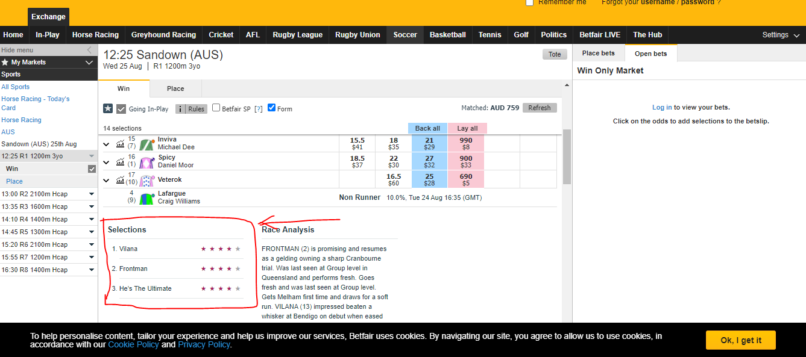

# Ladbrokes

All Races:

<https://www.ladbrokes.com.au/racing>

Tips example:

<https://www.ladbrokes.com.au/racing/belmont/479e59d8-e45e-49a5-b9f5-9362cf47f393>

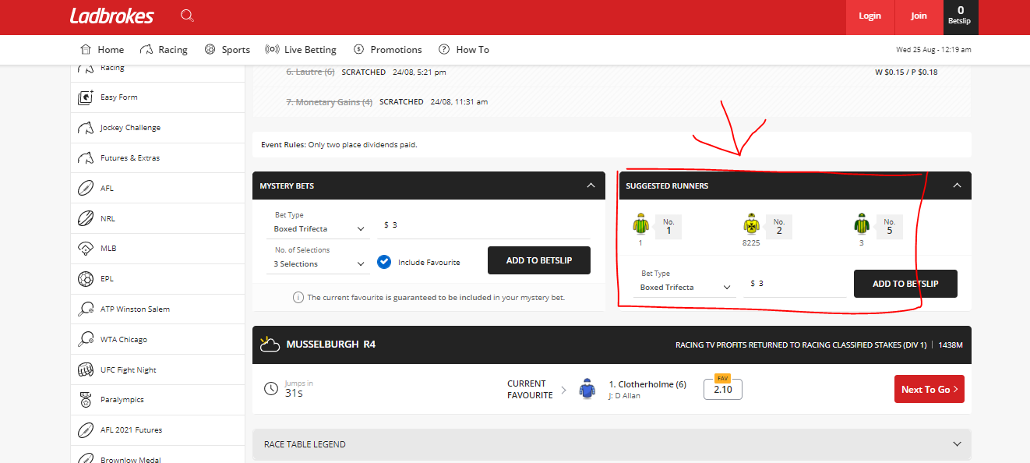

# Pointsbet

All Races:

<https://pointsbet.com.au/racing>

Tips example:

<https://pointsbet.com.au/racing/Thoroughbred/AUS/Belmont/race/16442758>

Click the preview and tips button

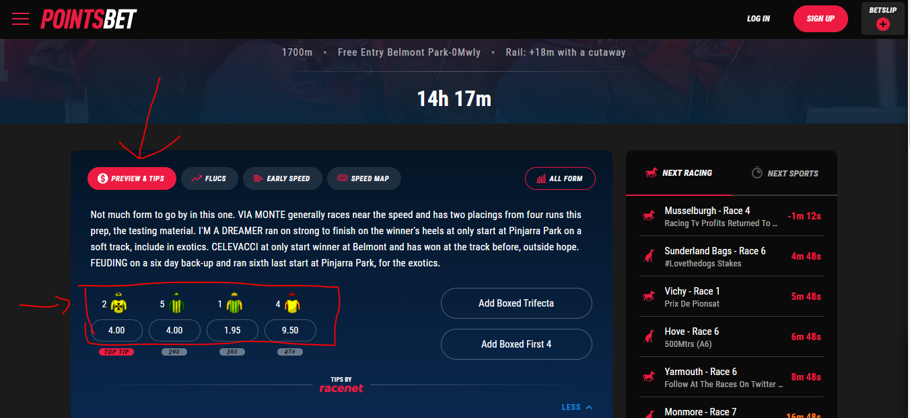

# Racenet

All Races:

<https://www.racenet.com.au/horse-racing-tips>

Tips example:

Click race to open tips

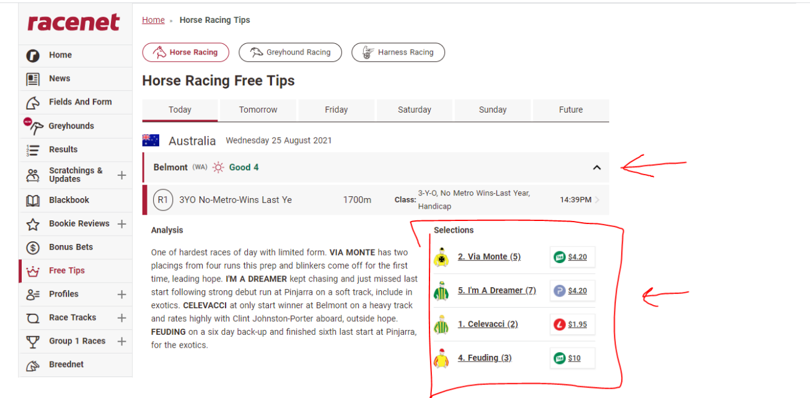

# Tabtouch

All Races:

<https://www.tabtouch.com.au/racing/races>

Tips example:

<https://www.tabtouch.com.au/racing/2021-08-25/pr/1>

Click race preview and numbers are displayed

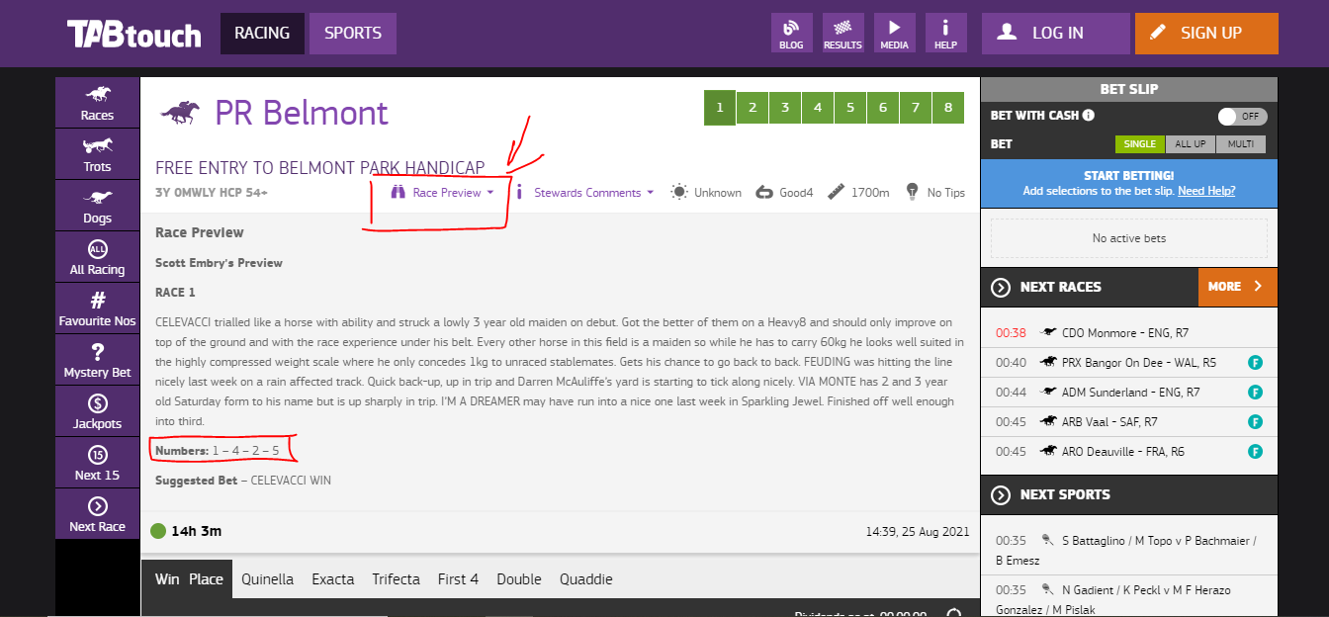

# TAB

All Races:

<https://www.tab.com.au/racing/meetings/today/R>

Tips example:

<https://www.tab.com.au/racing/2021-08-25/BELMONT/BEL/R/1>

Click Tips Tab and return all 7 sets of tips Each can have heading TAB-Best Overall, Tab-Skyform Rating,etc

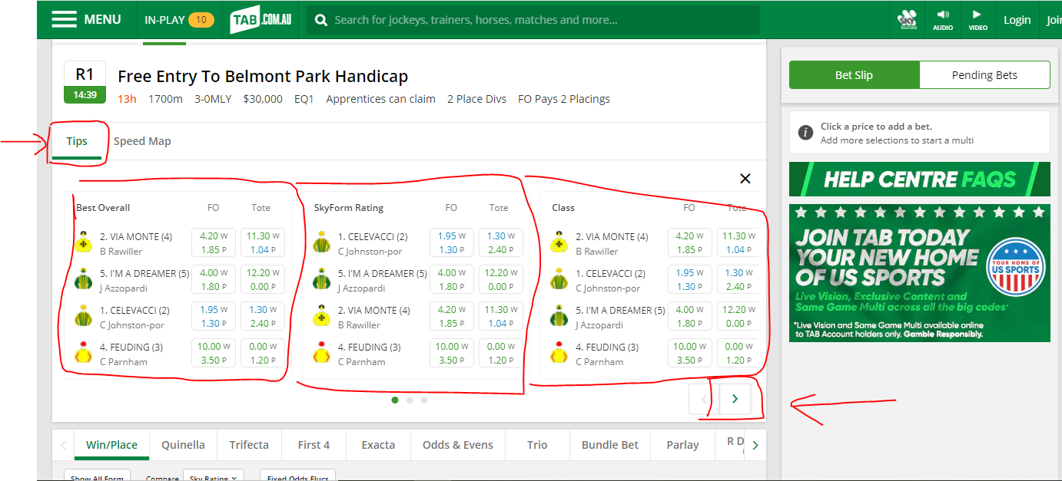

# Punters

All Races:

<https://www.punters.com.au/form-guide/>

Tips example:

<https://www.punters.com.au/form-guide/sandown-lakeside_204443/ladbrokes-punter-assist-plate-_1190904/#Overview>

The selection order is 2,3,8,10 however this is displayed as a percentage

